IT 599: Master Capstone’s in Information Technology
Assignment 2: IT Project Implementation Plan
Professor Lynne Williams
Jannaise Benitez
July 23, 2017

Assignment 2: IT Project Implementation Plan
Project Overview
The proposed health information system shall have the capability of automating the health sector through implementing different modules to support various functions in the area of health. The various system applications that shall support the area of health include the development of the patient registration module, the decision support module, the home patient mobile implementation and the distribution system for database support. The system registration system shall have the potential for handling data and information of individual patients by storing the data profile in an array of accounts as specified by the nurses. The data shall get updated every time the patient visits the hospital for health facilities. The decision support module shall have the capability of analyzing the patient symptoms and performing database mining to determine the specific diseases characterized by the symptoms as added in the data warehousing. The decision support module shall apply the intelligent systems to provide appropriate decision-making processes as specified by the doctors. The Health Information System shall implement the use of major and minor Unstructured Supplementary Service Data (USSD) to support the patients at home. The mobile module application shall be embedded in the smartphone and the old non-smart cell phone to facilitate patient guide and reminder notes. The Unstructured Supplementary Service Data shall inform the patients about the prescribed medicine schedule the time and the dosage to take. The mobile application shall also remind patients about the clinical dates on the reporting to the hospital. The Unstructured Supplementary Service Data shall be very useful in updating the patient. The mobile application shall also provide the user with the ability to initiate a direct chat for inquiries. The nature of the new application shall provide direct involvement by delivering health care services to the patient's premises during the time of emergency and in critical conditions.

Scope of the Project
The proposed project, the Health Information System intends to support both the public and the private health sectors. The system shall be limited to the health sectors of a limited number of actors. The officers within the Health Information System shall include the Administrator, the doctors, the nurses, the support staff and the patients. The various functions duties and responsibilities shall be defined within the operating accounts and the levels of system administration. The accessibility of the Health Information System services, privileges, and applications shall depend on the classification of the users in the scope. The Health Information System is neither limited to the particular operating system nor restrained to specific parameters of usage. However, the extent of use shall be restricted to the technology within fifty years. With future upgrading and review of documentation code for maintenance, the Health Information System can be upgraded to cope with future technologies as well.
Budget Estimation
The feasibility study indicated that the proposed Health Information System is economically feasible, operationally viable and the technically feasible. The calculation for determining the payback period proved that the project is possible for the health sector to invest. Overall the estimated budget of the whole health information system project is near $1,110,000 respectively.
Health Information System Budget
Health Information System Budget | Target 1  $ 600,000 | Target 2  $ 700,000 | Target 3  $ 900,000 | Target 4  $ 1,000,000 | Target 5  $ 1,110,000
Developers research | $ 140,000 | $ 130,000 | $ 120,000 | $ 110,000 | $ 110,000
Structural design | $ 180,000 | $ 115,000 | $ 160,000 | $ 115,000 | $ 160,000
Software components | $ 340,000 | $ 145,000 | $ 140,000 | $ 155,000 | $ 190,000
Hardware components | $ 230,000 | $ 117,000 | $ 130,000 | $ 140,000 | $ 170,000
Medical investigations | $ 120,000 | $ 145,000 | $ 140,000 | $ 150,000 | $ 180,000
Miscellaneous | $160,000 | $ 115,000 | $ 190,000 | $ 385,000 | $ 180,000
Total cost | $ 1,080,000 | $ 795,000 | $ 840,000 | $ 885,000 | $ 1,010,000
Non billed Operations
Fixed Systems Overheads | $ 300,000 | $ 300,000 | $ 300,000 | $ 300,000 | $ 300,000
Total costs | $ 1,280,000 | $ 887,000 | $ 950,000 | $ 995,000 | $ 1,110,000

Stakeholders
The stake holders of the Health Information System shall include the private health sectors, the government health sectors, and none- profit making organizations
Stake holders | Overview of the Health Information System requirements | Names
Private health sectors | Required a health system that can support the patients at their local premises | Chief financiers
Government health sectors | - Required a system that can track the returns on revenue taxed from health sectors  - Required system that can outline the report on consequence of diseases on population  - Required system that can show the death rate, the growth rate, and mortality rate | Investors and share holders
Nonprofit making health sectors | - Required a system that can analyze disease history  - Required a system that analyzes the trends of diseases | Support team
Developers | Planning, analyzing, designing, implementing, testing, installation, and deployment, | Heads of modular programming
Project manager | Controlling and managing entire process of developing the project | Project team leaders
Assistant project manager | Compiling deliverables | Student name

Table1: Stakeholders table

Stakeholders Strategic Alignment
The Health Information System supports the goals and objectives of the organization through the integrating the health operations within the system. The project development process involved the team of employees and major stakeholders in the implementation of the required goals and objectives. The development of the Health Information System shall strictly follow the procedures and directives of the project manager to implement the user requirements and the user goals. The Health Information System developers shall incorporate the key stakeholders in the development process to participate in the panel during the testing process. The key stakeholders shall have the responsibility of verifying and validating the functions of the developed system.

Stakeholders Environmental Analysis
The Health Information System is a dedicated system aiming at providing unique services to the final user with the intention of making the better system the total guarantee satisfaction of the user requirements and specifications. The Health Information System has been implemented in the private health sector but with limited features and functionalities. The existing system embraced by most of the private sectors constitutes a registration module, and basic operations within the health facilities like the pharmacy inventory systems, databases, inpatient and outpatient management systems as well as the user the analysis application systems. The proposed Health Information System is unique by implementing the additional modules like the USSD mobile application interface, the decision support interface, the big data support and data mining techniques. The quality of the system is best with significant weak implementation, development, and maintenance cost.
Project Benefits
The proposed Health Information System shall improve the medical services as well as monitoring of the patient's conditions in the most convenient manner according to patient’s needs. The entire system shall improve the processes involving the sharing of data and information through the implementation of the distributed system. The network shall get developed as viewed in the systems analysis process.
Health Information System is highly favored in the market due to its unique and user support services. The current health sectors require individual facilities to facilitate the accommodation of their customer and deliver satisfactory d\services to the patient. The targeted sector is fast growing with the demand to offer swift and reliable services within a short duration of time. The implementation of the USSD mobile system facilitates the quick communication procedures with the patients at any time locally and remotely. Thus facilitating easy accessibility, mobility and simplicity attribute required by the health investors.
The Health Information System business operations through the implementation of the centralized database systems, and centralized patients' point of services. The centralized approach guarantees data and information consistency and eliminates redundancy. The distributed systems are implemented through the network approach that enhances the sharing of data and information among the departments in the health sector. The Health Information System promotes the procedural models by automating primary operations outlined in line with the nature of the health services and appliances. The proposed system guarantees total compliance with the health sector processes and procedures and requirements thus providing the firm support to the business operations and appliances
The main areas involving the operational and strategic framework of the field of health affected by the implementation of the Health Information System includes the operational impacts and the health sector impacts. The area of health effects affected by the new system include the modification of the excel mode of data entry, change in the diagnosing procedures and parameters, change in the patient's access and communication with the health attendants.
The operation impacts affected by the application of Health Information System include the need for training the health support team on how to conduct registration of customers. Other users to be trained include the doctors on how to use the intelligent decision support system and patients on how to operate the USSDD mobile application.
I strongly recommend the entire health sector to invest in the proposed project for it is viable within all scopes of operation. The project is most recent with the application of most modern application methodologies and the implementation of the current trends in the economy. The functionality of the Health Information System guarantees a high level of scalability, availability, fault tolerance and user-friendly interfaces. The cost for the implementation is considered small with sufficient coverage of all required specifications and needs as stated in data collection session.
Returns on Investment (ROI)
The reports generated from the calculations on the Return on investments (ROI) showed that the figures were above the standards set by the whole sector. Health Information System had a Net Present value (NPV) acceptable by the health sectors thus making the assimilation and adoption of the project viable. The Constructive Cost Model (COCOMO) methodology of project cost determination proved that the budget estimated was appropriate for the health sector to consider the project viable. On behalf of the execution of the proposal to usage similar plan in emerging the existing EHR elucidation or "Health information management system" or HIMS invented to decrease the statistical errors in its supervision to demand the safety apprehension. The innovative project proposals the commendations for the association e.g. healthcare industry or hospital service to cope the vast quantity of statistics archives of the patient in a well-organized and safe mode. The plan will be implemented in a way to obtain the suggested technologies, tools, anticipated techniques as well as practices to achieve and scheme related arrangement of the program. The HIMS development will employ the implementation as well as design tools equally per approvals and expenditures to reward these methodologies in the organization. Further in future, we will work on the upgrade of the developed system for the recognized stakeholders by incorporating additional purposes of enhancing the manual process of the healthcare institutions.
Project Organizational Structure
The project comprises of different roles and accountabilities apart from project manager to build and implement such health info system solution for the administration. The administrative arrangement of the venture involves various functions and responsibilities like Project Head or Manager, business analyst, system analyst, web developer/designer, testing team, etc. The full administration roles and responsibilities are presented in the form of liability matrix shown below as:
Responsibility matrix
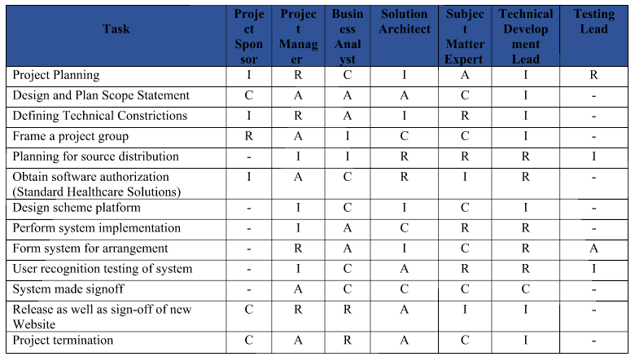
Project members’ roles and responsibilities
Roles | Responsibilities
Project Sponsor/head | System Initiation Sign-off and Budgetary regulations (concerns), sponsor whole project investment and actions
Project Manager | Administer project operations and accomplishes planning to implementation activities of the project
System Analyst | Analyst offers with accountabilities of project requirement analysis, planning, scope definition, etc.
Business Analyst | Performs the economic and business analysis of the project.
Solution Architect | The role comprises of design, building, coding, testing, and maintenance of the HIS application.
Technical Development Lead | This team looks for the major implementation and application development tasks.
Testing Lead | Testing the HIS application code and modules.

Work Breakdown Structure with Gantt chart
The Gantt chart with tabular form WBS of the “Health Information System” project is mentioned with included tasks, durations, dependencies, predecessors, milestones, and resources in MS Project (.mpp) file attached with the unit 2 assignment. The Gantt chart with WBS of the project is given below made in MS Project Professional tool.

Project Plan (including planned, scheduled tasks/activities)
Practically each of the healthcare associations had rigorous, long-lasting scheduling and expansion stages that convoluted “EHR customization,” maintenance procedure restructure to provision usage of the “HER,” in addition to end-user preparation. The “design, build, validate” stage acquired one year or (extra frequently) lengthier, resultant to a stunning introduction to diverse ambulatory and hospital locations/doctor practices crosswise a health framework, commonly through a “big bang” execution (each division at one time) inside any single hospice. Such form of “big bang” performance is frequently compulsory since of the inter-connectedness of every groups and framework inside a healthcare association. Even only healthcare organization, which revolved out EHR purposes in a couple of phases, highlighted the prerequisite to executing new functions cross ways all components in a competence at the similar stage (Chaulagai, et al., 2005). Simply two IT frontrunners preferred a phased methodology that permits for documentation of complications beforehand complete execution. The development and planning period diverse amid hospitals and frameworks, however, the particular interval from the choice to acquisition the EHR to execution was around "two to three years.” The project plan for our project appraisals for the “start and end date of each activity” besides the “level of effort” compulsory in every undertaking (Melin & Axelsson, 2014). For the research project on the implementation of the healthcare information system in the association as a client, we followed the qualified project plan given below in the document.
The project plan for our project appraisals for the “start and end date of each activity” besides the “level of effort” compulsory in every undertaking. For the research project on the implementation of the healthcare information system in the association as a client, we followed the qualified project plan given below as:
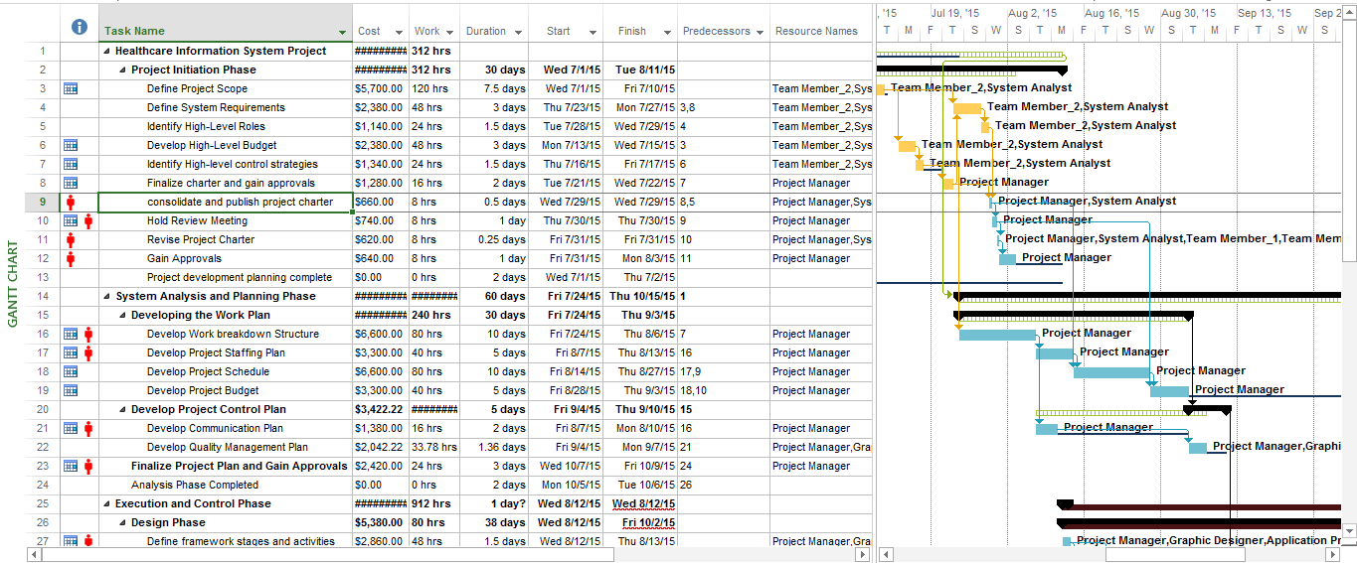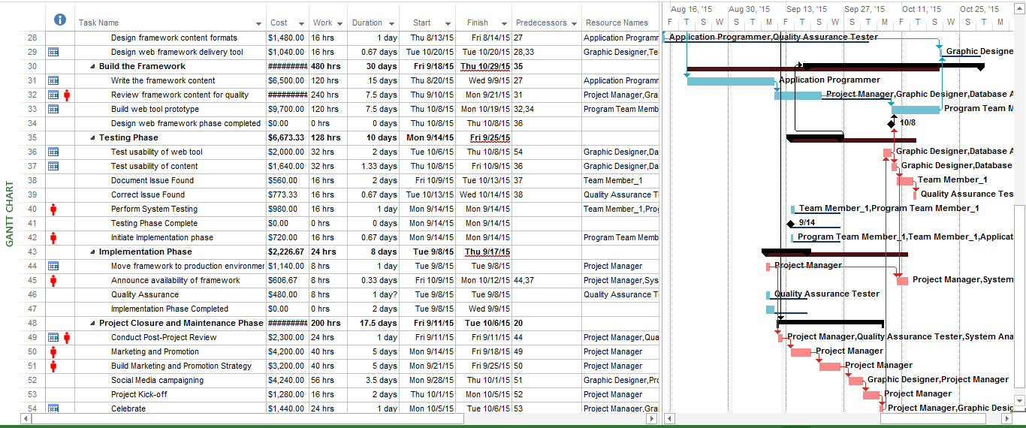

Resources
There are several possessions or resources in the arrangement of workforce persons that are subsidized in the accomplishment of the Healthcare information system development project, for instance, Project Supervisor, web developer, labor team, network administrator, web designer, core, and management team, IT expert, support team, core analysis squad and others. We are made a request to designate the assessed or speculated expenses to each of these individuals’ resources in the venture improvement (in dollars) frame. We relegated them as indicated by the standard charges every hour of the working in the enterprise. With each errand consolidating these individuals’ assets are apportioned with the dollars as the standard rates of business. These work and other venture expenses are appointed by the quantity of aggregate hours the property are working and utilized as a part of the research project plan.
“Table 1. Costs and resources of the project tasks.”
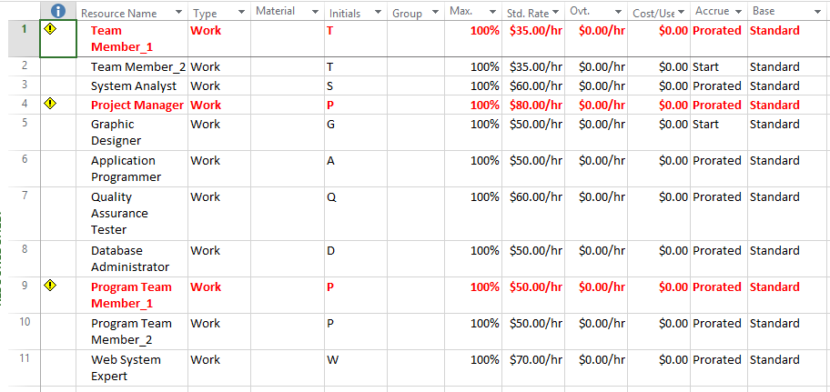
Critical Path with Milestones
The Project comprises of certain (2-4) key ways that consist of significant milestones in the schedule of the project. These are given in the (.mpp) MS Project file attached. The critical path is also demonstrated in the form of red color bars shown in the Gantt display area of the chart made in MS Project in the WBS and Gantt Chart section of the paper in the previous segment.

Risk Management Plan
Risk analysis
There are various risks involved during the project development like program module's implementation, cost estimation, budget requirements, problems, etc. The risks included the slowing of the project development. The risks and changes in the system or the project is on the organizational level, which has developed it and the change management involves the different strategies to implement and manage the project change. The risks embraced in project development of Health Information system to administer the healthcare patient records identified from security issues to the financial risks.
Project Risk assessment matrix
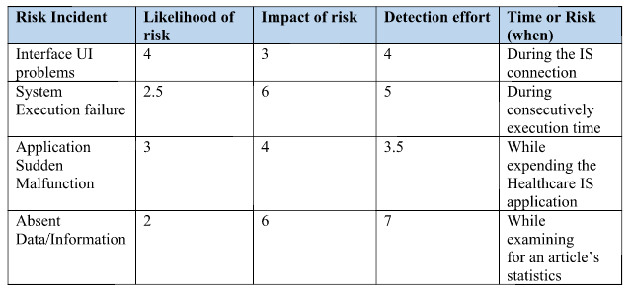
Risk Severity Matrix
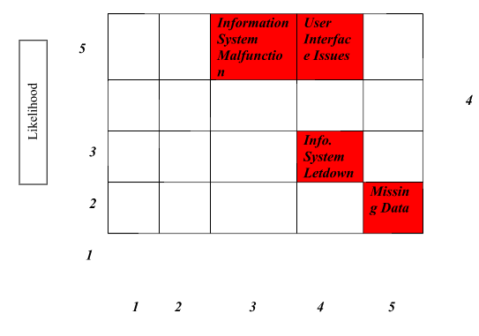Health Information System guarantees high-level fault tolerance characteristics. The Health Information System takes care of any occurrences related to the human error. The entire operations have a high level of modularity thus guaranteeing that the systems shall achieve active and continuous service provision. The modules shall be developed in such a way that they are i0ndependenkt of one another regarding opera rational and functionality rationale. Failure of a particular module shall not affect another module within the system. The Health Information System shall be designed such that when the system fails the entire transactions that were running during the crash time shall roll back to the initial state.

Risks on Contractual management tools
The Health Information System requires the human labor, the hardware resources, the software resources to accomplish the planning, designing, development, implementation, testing and installation among other Health Information System requirements (Gurupur, et al…, 2012). The human labor resources required include the database developers for implementing database design and coding. The system programs are needed to perform the various health functionalities. The project portfolio managers have an obligation to manage and control the project development process. The experts required during the different stages of development shall be employed under contract as well as through binding for the most technical applications within the process of development. The developing team shall acquire training from the experts during and after the session with experts.
The contractual hardware requirements tools include the use of the following utilities in the network
- The database server version 5.0 or above
- The computer workstations with hard disk drive of 1 terabyte and above
- The processing power of the workstations should be above 3.4 Gigahertz
The contractual software requirements tools include the use of the following
- Windows server operating system version 2008 or above
- Windows 8 or above for the workstation operating system
- The kernel drivers that support graphics with open gel files
Communication plan
The project correspondence plan offers supervisor that approved the changes. Then, the project executive implements the modifications instantaneously and overcome the tasks modeled by the variations in the Health Information System project proposal (Kerzner, 2004). The “Project communication plan” is shown as given below:
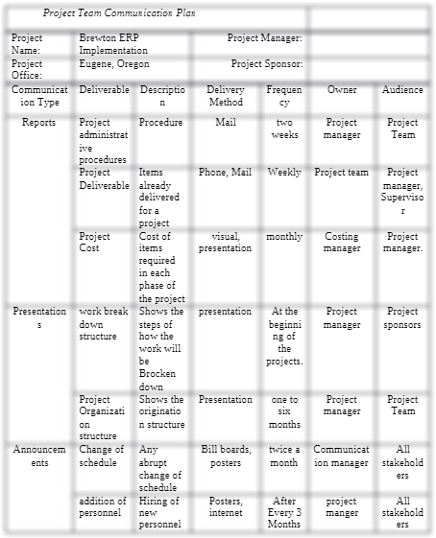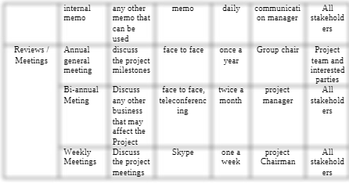
“Figure 1: Project Communication Plan” (Kerzner, 2004)

References
Almunawar, M. N., & Anshari, M. (2011). Health Information Systems (HIS): Concept and Technology. International Conference on Economics and Business Information, 9. doi:https://pdfs.semanticscholar.org/b634/db21a21c0e5dfebf87bc283d72507f37c9cc.pdf
Berg, M. (2001, December). Implementing information systems in health care organizations: myths and challenges. International Journal of Medical Informatics, 64(2-3), 143–156. doi:http://dx.doi.org/10.1016/S1386-5056(01)00200-3
Blavin, F., Ramos, C., Shah, A., & Devers, K. (2013, August 01). Final Report: Lessons from the Literature on Electronic Health Record Implementation. Retrieved from healthit: https://www.healthit.gov/sites/default/files/hit_lessons_learned_lit_review_final_08-01-2013.pdf
Chaulagai, C. N., Moyo, C. M., Koot, J., Moyo, H. B., Khunga, F. M., & Sambakunsi, T. C. (2005, September 02). Design and implementation of a health management information system in Malawi: issues, innovations and results. The London School of Hygiene and Tropical Medicine. doi:10.1093/heapol/czi044
Gladwin, J., Dixon, R. A., & Wilson, T. (2003). Implementing a new health management information system in Uganda. Health Policy and Planning, 214-224.
Khalifa, M., & Alswailem, O. ( 2015 ). Hospital Information Systems (HIS) Acceptance and Satisfaction: A Case Study of a Tertiary Care Hospital. The 5th International Conference on Current and Future Trends of Information and Communication Technologies in Healthcare (ICTH 2015), 198-204. doi:10.1016/j.procs.2015.08.334
Kouroubali, A. (2003, June). Implementation of Health Care Information Systems:. Retrieved from semanticscholar: https://pdfs.semanticscholar.org/6a7a/a2eb1aadc3a5409e477735f4f89cfa89bc4b.pdf
Melin, U., & Axelsson, K. (2014). Implementing Healthcare Information Systems: Mirroring a Wide Spectrum of Images of an IT Project. Health Policy and Technology, 3(1), 26-35. doi:http://dx.doi.org/10.1016/j.hlpt.2013.11.001
Ngafeeson, M. (2014). Healthcare Information Systems: Opportunities and Challenges. The Commons.
Omachonu, V. K., & Einspruch, N. G. (2010). Innovation in Healthcare Delivery Systems: A Conceptual Framework. The Innovation Journal: The Public Sector Innovation Journal, 15(1), 2-18.

